Disability Inclusion Mentoring Program (DIMP) for Organisations
CII – IBDN Mentor Club network is being established as a pan-India initiative for companies to build and strengthen their disability inclusion journey. The program will assess the needs of companies looking forward to initiating their disability inclusion journey and matching them with Industry members who are seasoned champions in the space.
The program will harness the experience and learnings of disability inclusion champion companies through a designed 6 month long program, where mentee companies will receive mentorship from the champion companies.

Mentorship components:
- Experiential visits to the workplace of champion companies:
Includes a full day visit to the work site of mentor company, to gain a first-hand understanding of how the company has integrated disability inclusion at the workplace/unit

Sessions with the mentor companies:
Structured conversation with the mentor company leadership, D&I team and employees with disabilities

Developing the Disability Inclusion workplan of Mentee companies:
Mentee company would develop its own disability inclusion strategy/roadmap under the guidance of the mentor company. This may include one or more of the following practices:
  - Disability inclusion policy
  - Sensitization of staff
  - Ensuring accessibility (physical and digital)
  - Job Mapping and hiring solutions
  - Building inclusive culture

Mentor-Mentee Hotline:

The Mentor organization would be the ‘friend, philosopher & guide’ for the mentee company and be available for call conversations to guide the mentee in its inclusion journey

Mentorship Duration
The Mentorship program will be developed in lines of a project with a start and end date. This would ensure that the interactions are structured with constructive exchange and meets the end objectives of the participating companies.
The duration of the mentoring would be six months, requiring:
- Time commitment of 4-6 hrs in a month, which maybe physical/virtual or telephonic.
- One physical experiential visit to workplace of Mentor Company
The Mentor and mentee companies are free to continue with their interaction, post the mentorship officially ends.

Success Indicators
•Additional elements added to make the disability inclusion engagement
more robust/stronger
•Identified problems resolved by the end of the mentorship period
•Hiring and recruitment of PwDs initiated or increased
•Additional linkages and partnerships established

MENTORSHIP PROCESS DESIGN
CII IBDN will be anchoring this process with the industry and sector experts from the industry with an objective to introduce, enhance and strengthen the disability inclusion practice of a company. This will be achieved through direct and indirect initiatives as under:

Direct Interventions | Indirect Interventions
Increase knowledge, experience and problem Solving to address current issues and asks that the companies might be dealing with, towards introducing or strengthening the disability inclusion practice | Increase companies’ connect with people and networks so that they can potentially access resources and knowledge (IBDN membership, Conferences, seminars, valuable 500)
 | Providing templates and knowledge resources such as publications, EOP templates, inclusion frameworks etc
 | Enhance capabilities through Capacity Building programs

While the IBDN will be working on an ongoing basis on the indirect interventions, the mentoring process will fall on the direct intervention.

The coaching process will be 6 months with a minimum of 4+1 meetings (1
experiential visit to the mentor company’s location).

Mentor Faculty profile will be featured on CII- IBDN website and a big shoutout will be given to both mentee and mentor on all CII - IBDN social media platforms.

Introductions | Anchor (IBDN) call facilitated | Understanding the objective and work of mentee company and identifying the work area(s) for the mentoring process.  - Introductions  - Areas the mentor and mentee would like to engage on  - Expectation setting  - Identifying some action areas  - Defining the timelines (call/meeting schedules over the next 6 months and planning the on-site visit)
Meeting 1 | 1 hour – Telephonic or via Web | - A connect phone call to follow up on any actions that were decided upon in the introductory meeting  - Conversation on challenges and new steps
Meeting 2 ++ (shorter intermittent calls) | 1.5 hours – Telephonic or via Web | Taking the conversation forward – discussing challenges and action points  - Guidance by Mentor company  - Mentor may connecting mentee with relevant stakeholders/solution providers
Meeting 3 | 1 hour – Telephonic or via Web | Connect call with CII-IBDN and Mentee to do a mid-way check on the process Addressing any other issues
Meeting 4 | 3 hours- Experiential visit | Follow up on action steps  On-site experiential visit to mentor  company location

 |  | Interaction with management & employees : To understand the inclusion eco-system of the Mentor company
Conclusion | 1 hours – Telephonic or via Web | Wrap up and Conclusion  - Mentor & Mentee may share their experience  - Present how the problem statement as defined in the introductory call, was  addressed

Tips on planning the coaching process effectively

GETTING STARTED
Item on Agenda | Description of Item
Introductions | Introduce yourselves along with your expertise and background
Agenda | What is needed for the session Duration of the session
Setting the Context | What are your expectations? What is your time availability? What you can/cannot do
Mentee to give an overview | Of their businesses  Of their inclusion experience/practices Of their strengths and weaknesses
Building agreement on objectives and purpose | Where is help needed  What does the mentee hope to achieve

Building agreement on future processes | Frequency of meetings Where/How to meet  Preparation by both parties for future Reporting to Anchor organization (IBDN team)

Planning the six-month process
  - Build broad agreement and set expectations with your mentee on the goals and objectives that you jointly wish to achieve through the mentoring exercise.
  - Establish the non-negotiables in your relationship
  - Set a broad timeline/calendar across the next 6 months for your meetings

Planning individual sessions
Before and after each session, you may want to:
  - Plan your sessions ahead
  - Document the highs and lows of each session and the decisions arrived at
  - Analyze each session

Please ensure that each session is for a duration of 1.5 hours. It is preferred that you conduct as many face-to-face engagements as possible; else you can conduct online meetings.

PROCESS FLOW

In order to further assist you in conducting successful sessions with your mentee we have created a framework that provides a basic process flow that you may wish to refer to.

This process can foster a methodology to extract the most out of your mentoring sessions. Although every session is individual in nature, this flow can be used as a broad guideline to achieve big picture outcomes while structuring and conducting the session. A model process that could be followed for this coaching process is as under:

MENTOR-MENTEE SESSION FLOW

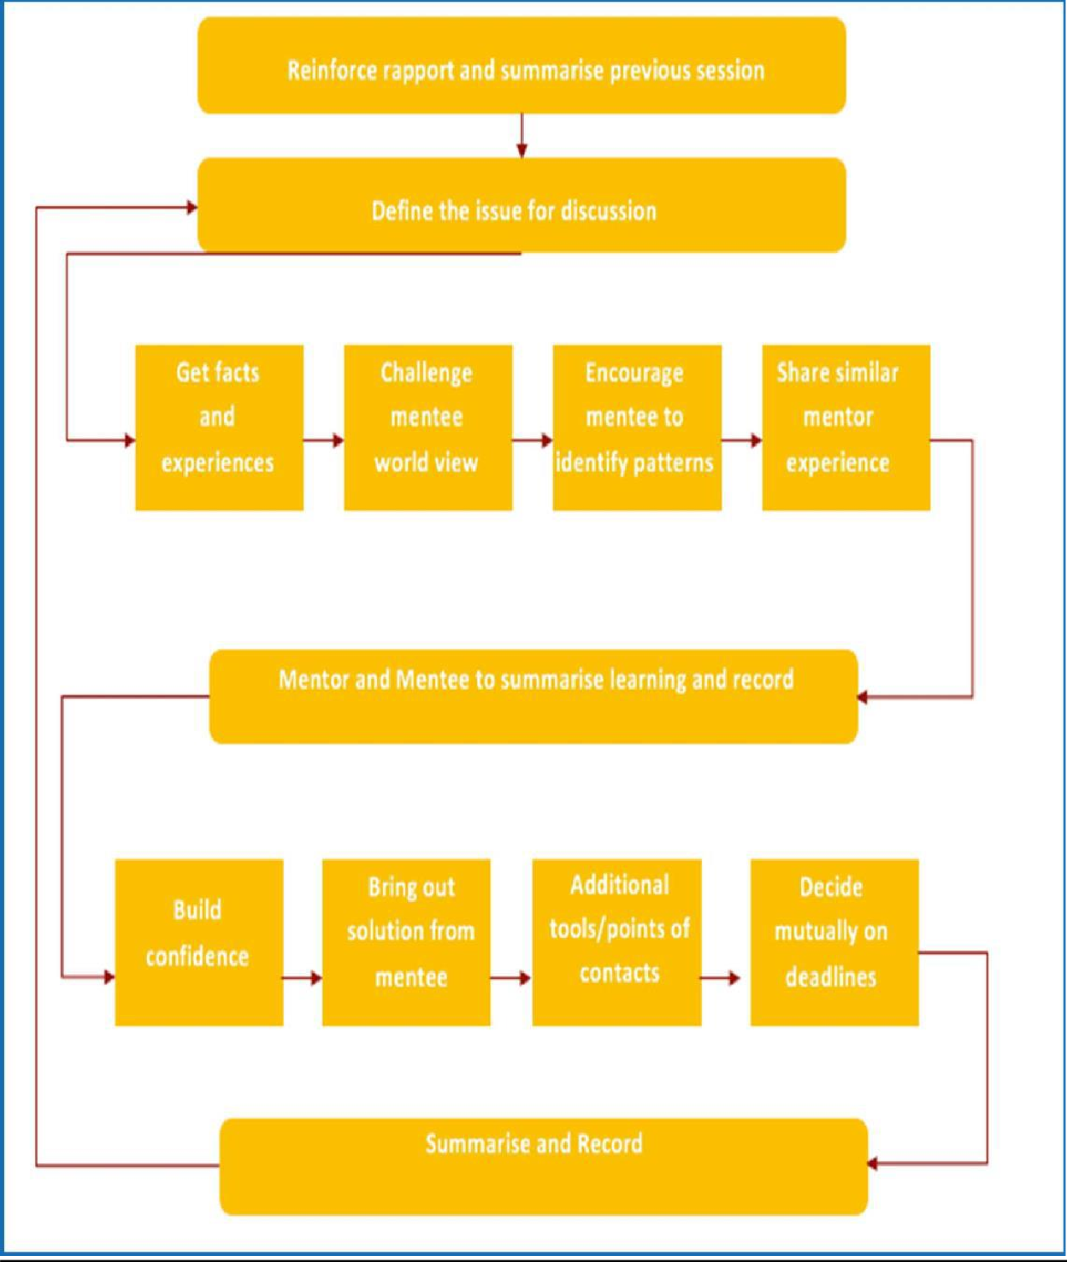

SESSION REPORTING TEMPLATE

After every session fill in the reporting format to share plans and observations with the team.

This template can be used to report the outcome of each session. It provides a quick way to cover all the vital reporting check points in order to efficiently follow up, analyse, enhance and establish the mentorship process. The template will be filled up by the mentor after each session and shared with the IBDN team within one week of each discussion.

Particulars | Detail
Date
Session Number
Mode of the session
Duration of the session
Follow up session scheduled for:

- Please describe the goal/agenda set for this session:

- What were the key discussion points that emerged?

- What were the key agreements between the mentor and mentee?

- Key challenges faced?

- Key learnings:

- Any specific information/contact shared to facilitate the goal

- What are the next steps designated towards the goal?

- Any anecdote or details that you would like to highlight?

- Photos from the sessions

Note: The Mentoring Program will be rooted on candid exchange between mentor & mentee. The role of the anchor, therefore, would be limited to the introductory meeting, post which the mentor and mentee may take forward one-to-one conversations. The reporting template would help the anchor to understand whether the program is on track, taking a positive direction and if any calibration is required.

FAQ’s for the MENTOR

Q. What is my role as a Mentor?

As a mentor, we will urge you to:

- Build confidence of mentee company in engaging with the sector
- Capacitate the mentee to increase the company’s understanding of strategic planning and execution of inclusion practice within the company
- Connect mentee company to new resources, people, organizations in the sector

Q. What is the bare minimum I need to commit to as a mentor?

The bare minimums you are expected to meet by the end of this program are:

- 1 Meeting with a Field Visit
- 5 mentoring sessions physical/online or on call
- Meeting progress reports
- Liaison with the CII-IBDN team and the mentee company

Disability Inclusion Mentoring Program (DIMP)

ENROLLMENT FORM - MENTOR

NAME OF ORGANISATION:

SECTOR:

CONTACT POINT NAME:

EMAIL:

CONTACT NO:

IBDN MEMBER: YES/NO

PREFERRED LOCATION(S) (City):

MENTORSHIP AREAS/ AREAS OF EXPERTISE:
- Developing Disability Inclusion Strategy
- Creating Accessible Workplace
- Developing Disability Inclusive Culture, (approaches / initiatives to build inclusive culture)
- Job Mapping, Hiring and on-boarding PwDs at workplace
- Developing Policies (Equal Opportunity Policy, HR and other employment policies, especially for PwDs)
- Understanding Neurodiversity and its inclusion at workplace.

Disability Inclusion Mentoring Program (DIMP)

ENROLLMENT FORM - MENTEE

NAME OF ORGANISATION:

SECTOR:

CONTACT POINT NAME:

EMAIL:

CONTACT NO:

PREFERRED LOCATION(S) (City):

IBDN MEMBER: YES/NO

MENTORSHIP AREAS:

- Developing Disability Inclusion Strategy
- Creating Accessible Workplace
- Developing Disability Inclusive Culture, (approaches / initiatives to build inclusive culture)
- Job Mapping, Hiring and on-boarding PwDs at workplace
- Developing Policies (Equal Opportunity Policy, HR and other employment policies, especially for PwDs).
- Understanding Neurodiversity and its inclusion at workplace.

